SEMESTER ONE

MATHEMATICS METHODS

UNIT 1

2015

SOLUTIONS

SECTION ONE

1. (5 marks)
(a) Simplify, leaving answer with positive integers (2)
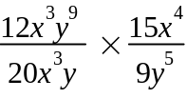
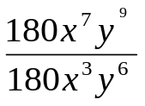 ✓

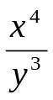 ✓

(b) The wage is increasing at a rate depending on the number of buckets
✓
that have been filled with fruit. Hence it is an example of direct proportion. (1)

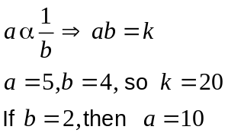
(c)
✓ (2)
✓

2. (a) M(6, 5) ✓

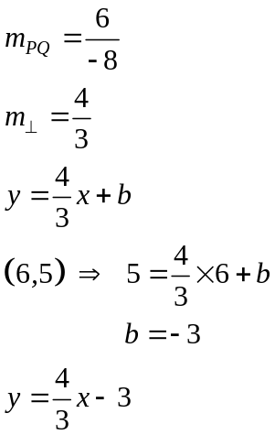
✓
(b)
✓

✓ ✓

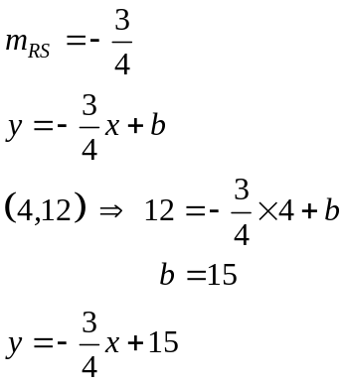 (c)

✓
✓

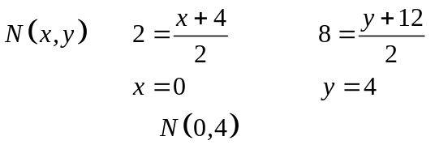
(d)

✓✓

✓
(e) IPQI = √ (10 -2)² + (2-8)²
= 10 units ✓

3. (a) 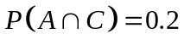 ✓
(b) 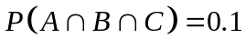 ✓
(c) 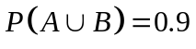 ✓
(d) 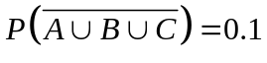 ✓✓
(e) 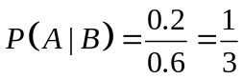
✓ ✓
(7)

4. (a) 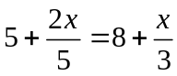
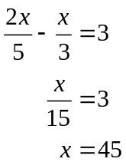
✓
✓

(b) 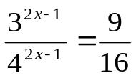

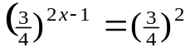 ✓
2x -1 = 2 ✓
x = 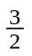 ✓ (5)

5. (8 marks)
A dog breeder has 60 dogs in his kennels. 40% of the dogs are Labradors, and all the rest are either Poodles or Dalmatians. There are half as many males as females, but only a quarter of the Poodles are male. There are 12 female Poodles and 3 male Labradors.
a) Complete the two-way table below. (3)
 | Poodle | Labrador | Dalmatian | Total
Male | 4 | 3 | 13 | 20
Female | 12 | 21 | 7 | 40
Total | 16 | 24 | 20 | 60

b) What is the probability that a randomly chosen dog from this group will be?

- a Dalmatian? 20/60 = 1/3 (1)

- a female Labrador? 21/60 (1)

- either female or a Poodle? 44/60 =11/15 (1)

- a female, given that it is a Poodle? 12/16 = 3/4 (2)

6. (a) (i)
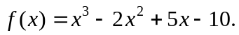
✓
f (2) = 2³ – 2(2)² + 5(2) -10 = 0

(ii) f (x) = (x-2) (x² + 5) + 0
✓✓

(b) (-2, 1), r = 3 ✓ (4)
7. (a) If 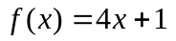 and 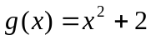
Find the following
(i) 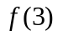 = 4(3) +1= 13 ✓
(ii) 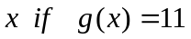 = 11, x = 3, -3 ✓ (2)

(b) State the domain and range for the function 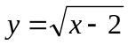
D: x E R, x ≥ 2 ✓ R: y E R, y ≥ 0 ✓ (2)

(c) A parabola has equation y= f(x) where f(x) = k(x - a)² + 16 where a is a constant
Find a and k if the parabola has a turning point at (2,16) and f (0) = -4 (2)
a = 2 ✓ k= -5 ✓

8. (4 marks)
Match the graphs drawn here with their corresponding equations from the set below the graphs:

A: y = 3^{x} ✓
B : 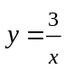 ✓
C: 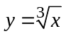 ✓

D : 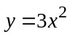 ✓

END OF SECTION ONE

SECTION TWO

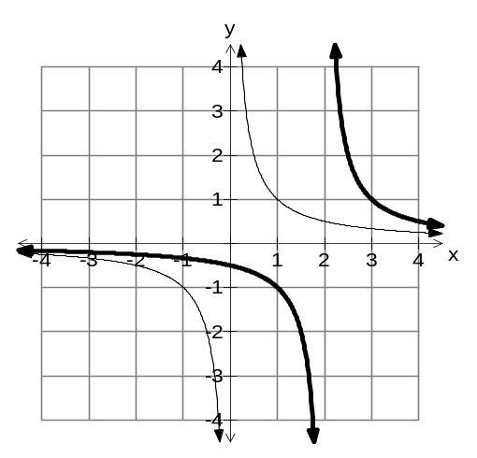9. (a)

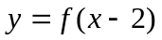
✓✓

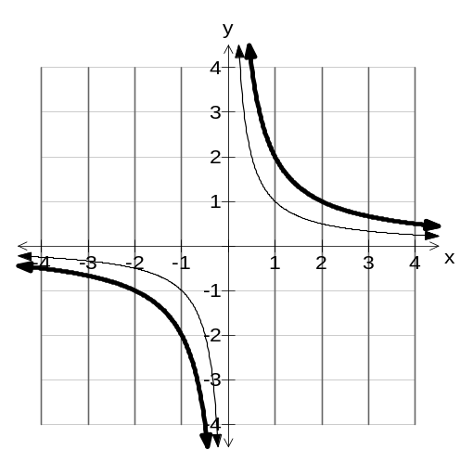
(b)
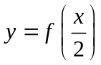
✓✓

(4)
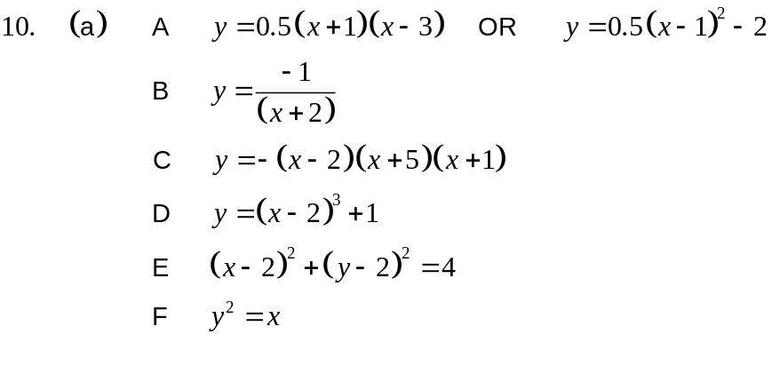
✓
✓
✓✓
✓✓
✓✓
✓
(b) E and F
✓
For every x value there is not a unique y value.
✓

(c) P Maximum turning point
Q y intercept
✓
✓
R Axis of symmetry
✓
S x intercepts (15)
✓
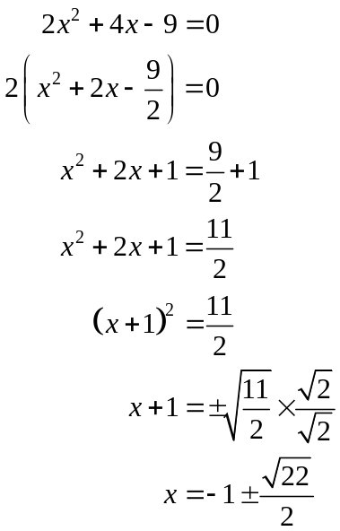11. (a)

✓
✓
✓
✓

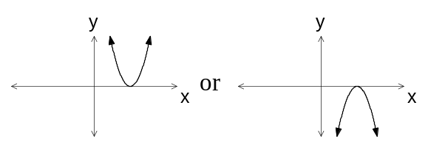 (b) (i) Δ = 0
✓ ✓ (One diagram is enough)
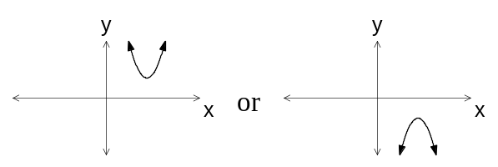
(ii) Δ < 0
✓ ✓

(c) (i) x = -3.45 or x = 1.45
✓ ✓
✓ ✓
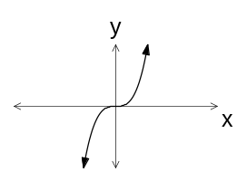 (ii) x = -13

✓
(d) (i) one zero
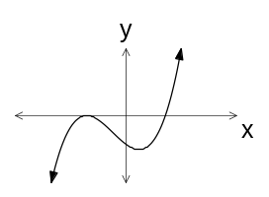

✓✓

(ii) two distinct zeroes
(15)

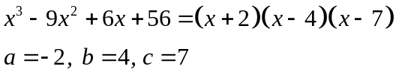12. (a)
✓
✓ (any order)
(b) At x = 6, x – 7 = – 1. The box has a side that has negative length, so x ≠ 6.
✓
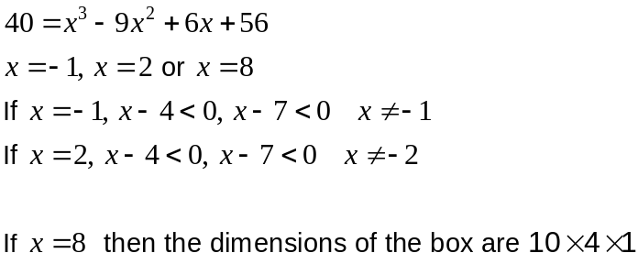(c)
✓

✓
(5)
13. (a) Find the radius and the coordinates of the centre of the circle:
x² + y² + 2x = 6y +15 (3)
x² + 2x + y²-6y= 15
(x +1)² + (y-3)² = 5² ✓
Centre: (-1,3) ✓ radius: 5 ✓

(b) Points A and B lie on the circumference of a circle, centre O and radius 15 cm.
If the minor arc AB subtends an angle of 0.8 radians at O, find
(i) the length of the minor arc AB = 15 x 0.8 = 12 cm ✓ (1)
(ii) the area of the major sector AOB = ½ x 15² x (2π- 0.8) = 616.86 cm² ✓✓ (2)

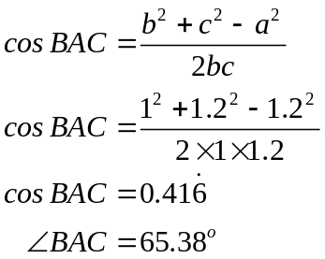14. (a) (i)
✓
✓

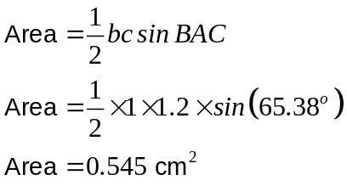 (ii)
✓
✓

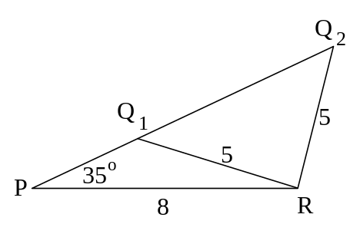
(b)

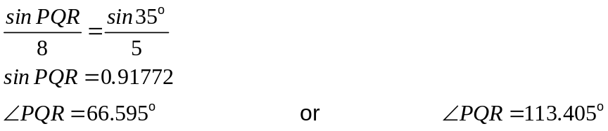
✓
✓
✓
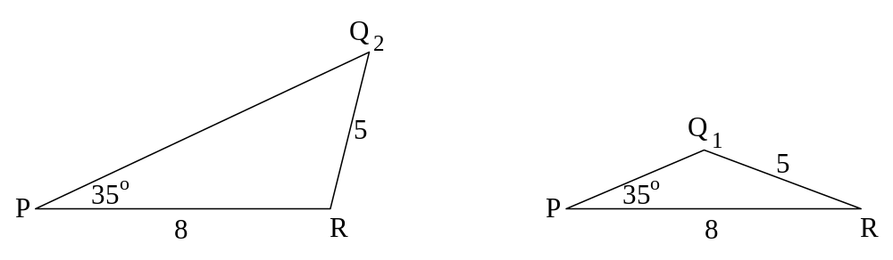

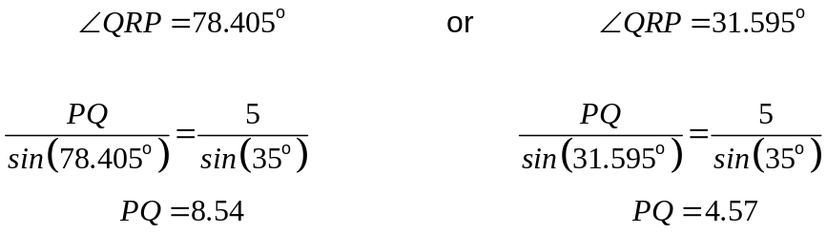
✓
✓

✓
✓
(11)
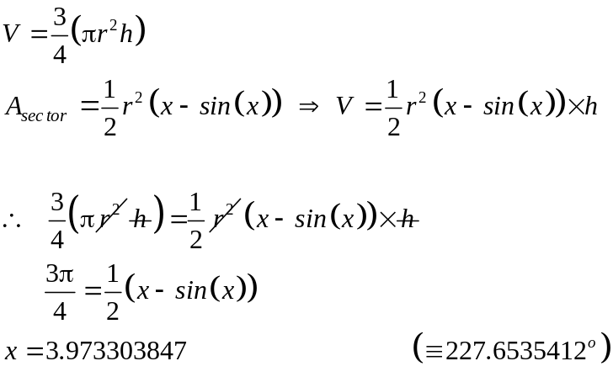15. (a)

✓ ✓

✓
✓

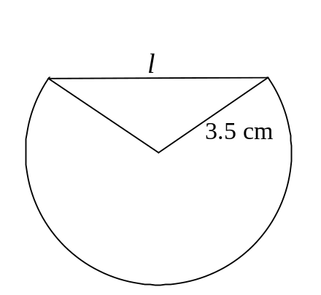 (b) Angle required
✓

132.3º
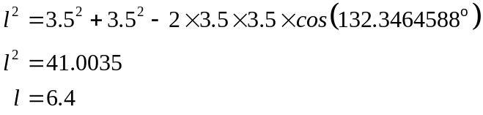
✓

✓
✓

The length of the chord is 6.4 cm.
(8)

16. (a) The curve y= 5^{x} is transformed into y= 5^{x+1} – 1. State the transformations involved. (2)
Translation 1 unit to the left (✓) followed by a translation 1 unit down (✓)

(b) Amoeba in a petri dish multiply under laboratory conditions according to the rule 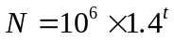where t is the hours from the first estimate of the number of amoeba.
(i) Find  when . N = 10⁶ ✓ (1)
(ii) Find when 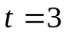. N = 10⁶ x 1.4³=2744000 ✓ (1)
(iii) How long does it take for to
(i) double? 2.06 hours ✓ ✓ (2)
(ii) treble? 3.27 hours ✓ (1)
(iv) Estimate 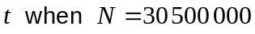. (2)
t= 10.16 hours ✓✓

17. (5 marks)
(a) Calculate 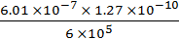 and write the answer in
Scientific notation, rounded to two significant figures (2)
1.3 x 10⁻²² ✓ ✓
(b) The numerator of a fraction is 3 more than the denominator. The sum of the numerator and the denominator is 11.
(i) Write two simultaneous equations from this information (2)
Let the numerator be x and the denominator be y
x + y = 11
x = y + 3 ✓✓
(ii) Hence, determine the fraction
7/4 ✓ (1)

18. (a) (i) 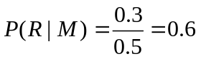
✓✓

(ii)
✓

(iii) 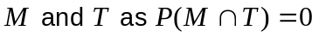
✓

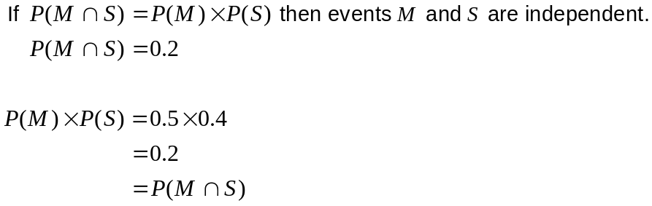 (iv)
✓

✓

✓

Therefore the events M and S are independent.
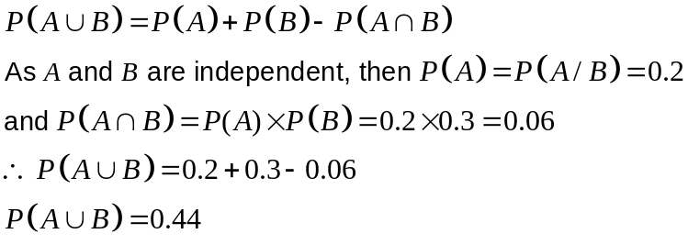(b)
✓

✓

✓

✓

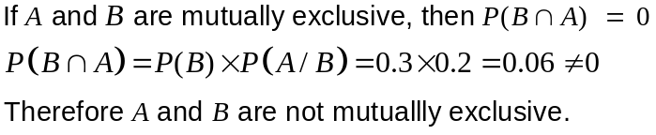 (c)
✓

(12)

19. (a)
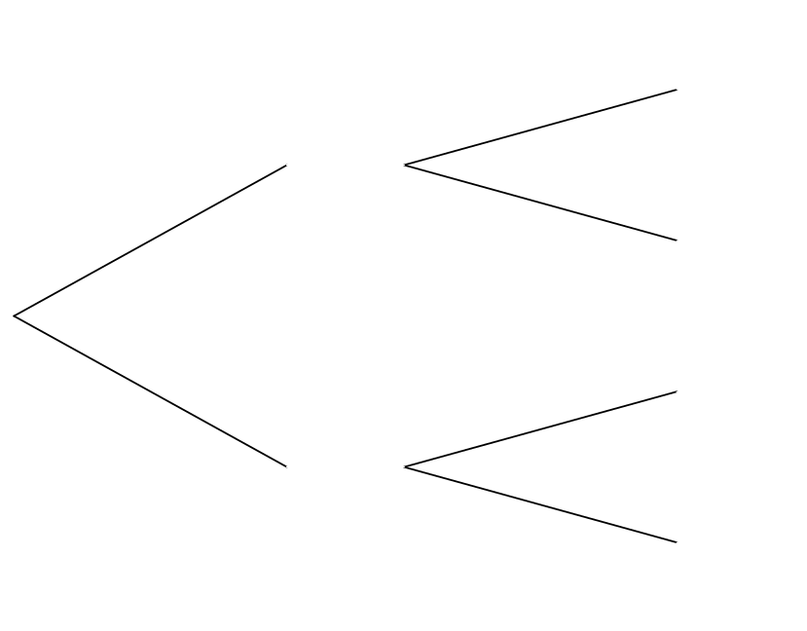
✓


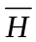

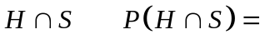
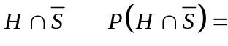
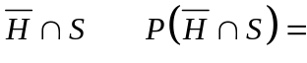
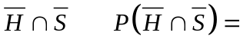
0.3
0.7
0.4
0.6
0.12
0.18
0.3
0.4
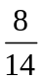
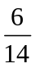
✓

✓

✓

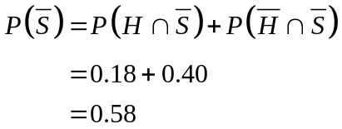 (b) (i)
✓

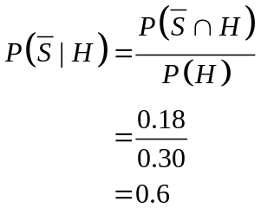
(ii)
✓

✓

(c) If events H and S are independent then 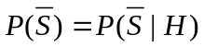
✓

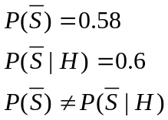
✓

No, the events are not independent.
Therefore the health food has an effect on the length of the symptoms of a cold
✓

(but only marginally).
(10)
END OF SECTION TWO

